When the North Pole

Became Too Cold

As told to Grandpa Beach

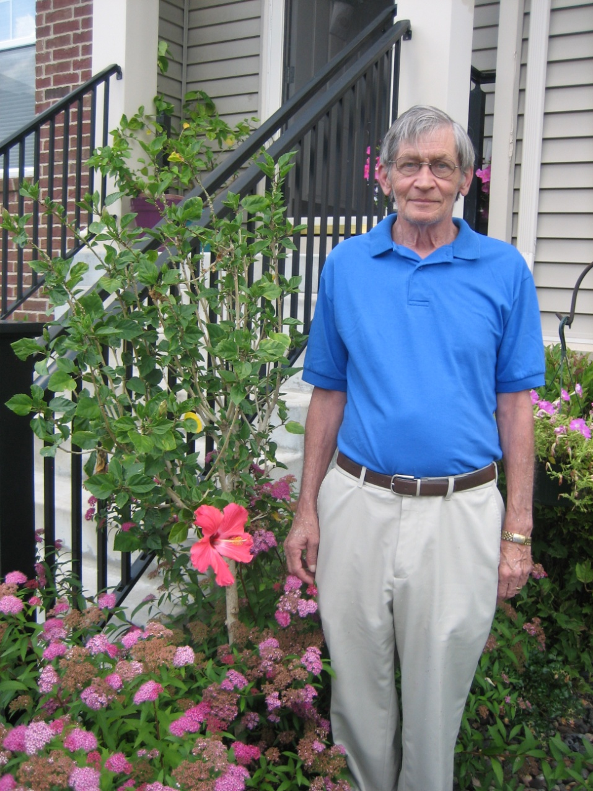



School Version-Older Kids

Copyright © 2013 Xanadu Inc. See Instructions on uses permitted, copying and tailoring to your child/children.

**It was so so cold the bicycles had icicles.**

**It wasn’t fair there was cold everywhere.**

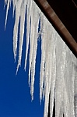

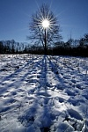

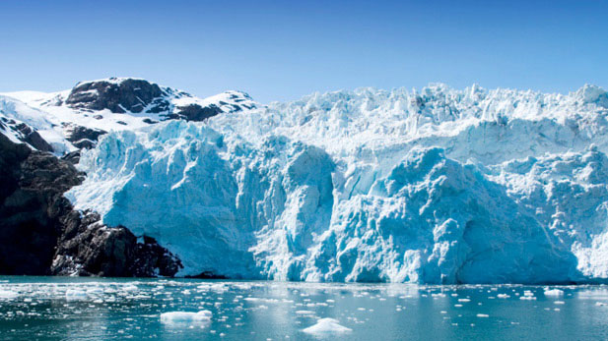

**The sun came up for only**

**one hour. This made the**

**elves quite sour. The snow**

**was in lumps giving**

**everyone goose bumps.**

T**he temperature kept dropping.**

**It seemed like there was no stopping.**

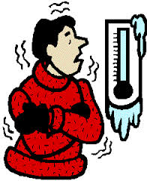

Everyone shivered

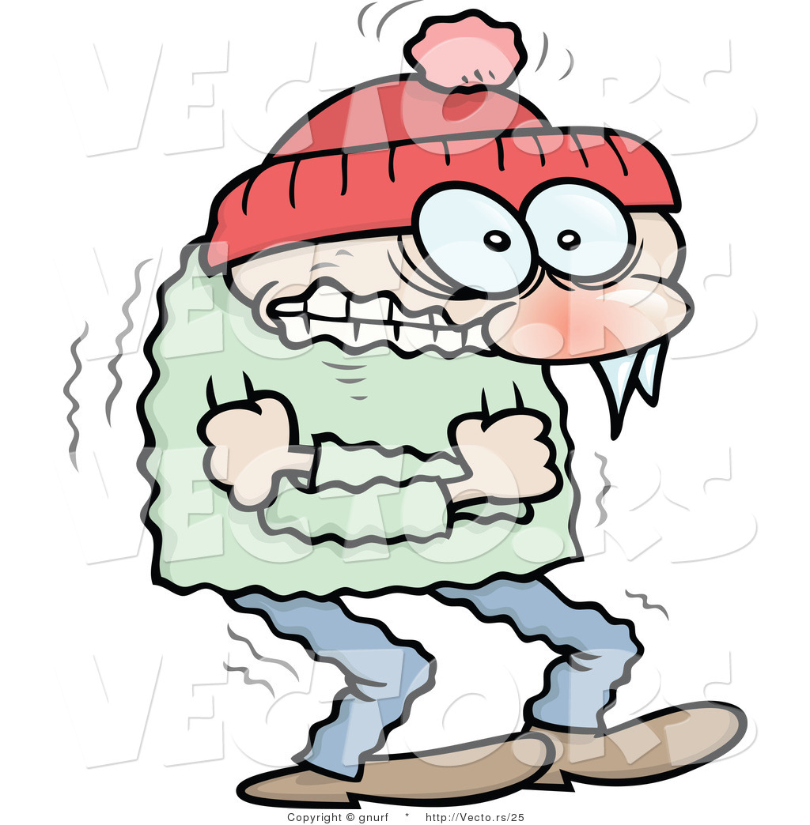

**Especially**

**the elves**

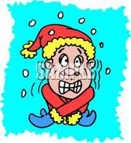

It was so cold!!!

The chubby penguin’s toes froze.

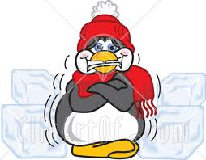

Frosty felt he would never melt.

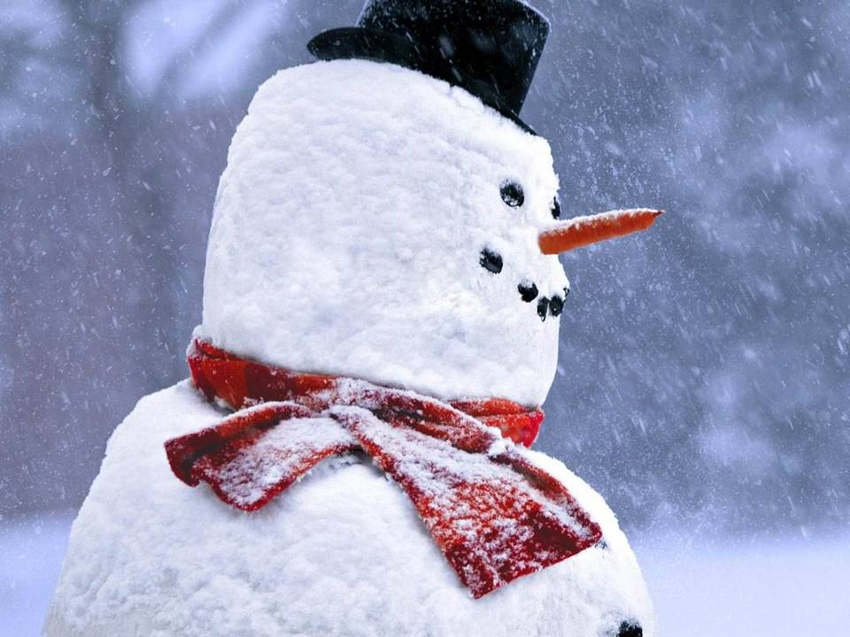

**The cold and ice stole**

**all the fun at the North Pole.**

**They called the furnace doctor**

**And you can be sure**

**He tinkered and tried**

**But couldn’t get a temperature.**

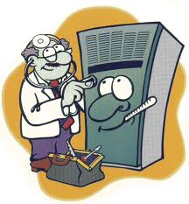

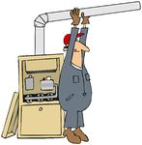

**It wasn’t fair.**

**There was no warm air.**

The polar bear hid his eyes

and sat on a rock.

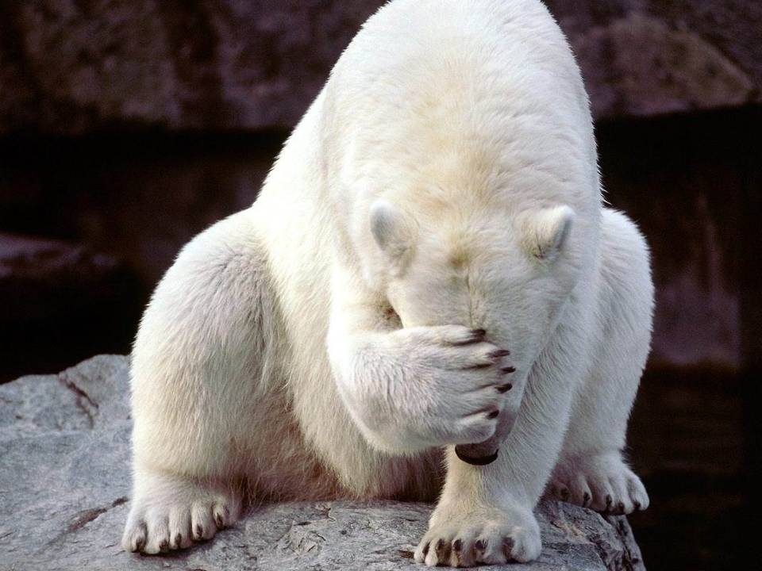

**At the North Pole there was no joy.**

**It was too cold to make even one toy.**

**The poor bear shivered and shook**

**And was so sad he couldn’t look.**

Bad luck. The baby seal got stuck.

It wasn’t nice napping on the ice.

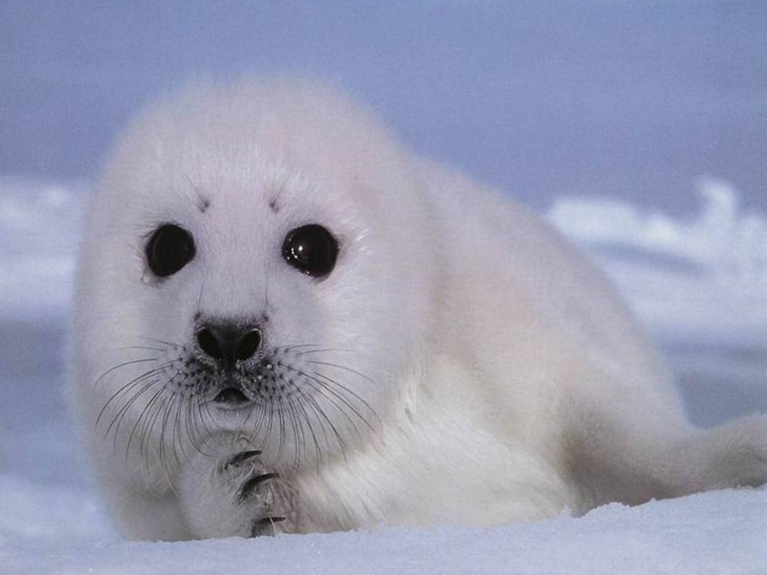 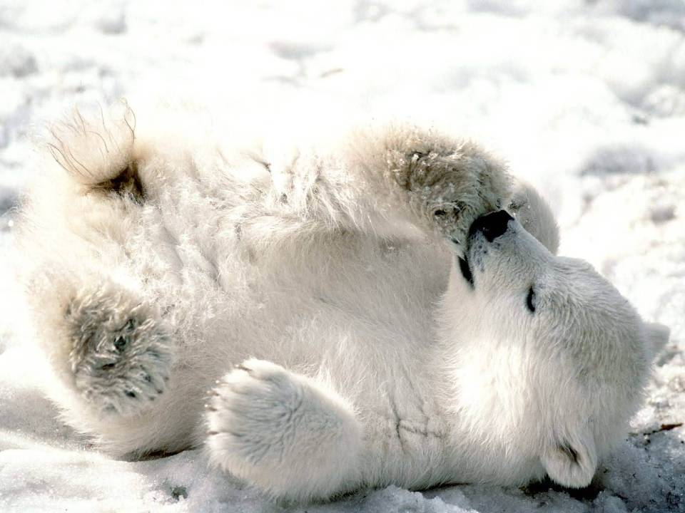

The penguins had a race to leave the place.

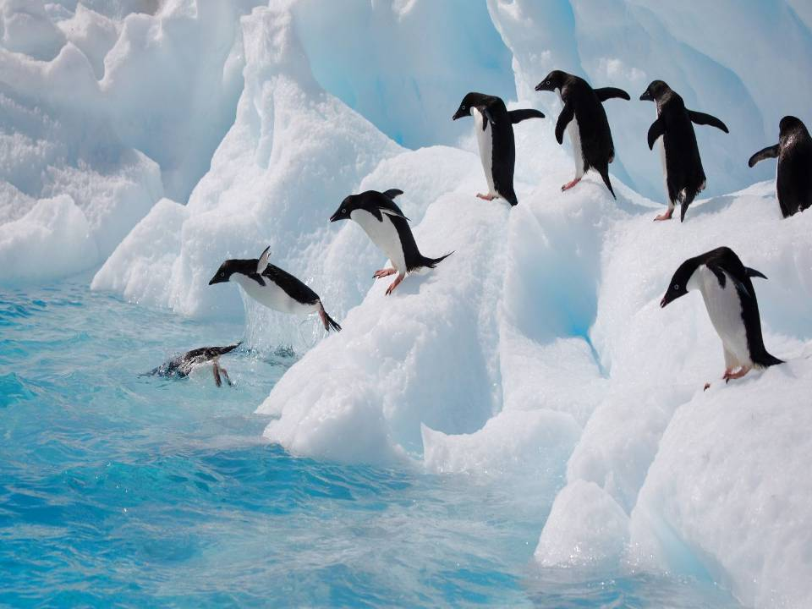

Santa said, “I’m sorry to say

we may need to cancel the holiday.”

**“Cancel Christmas what a thought.**

**No gifts to give the children will be distraught.”**

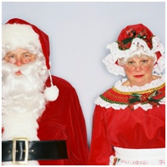



“Oh me, oh my.

All the children will cry.”

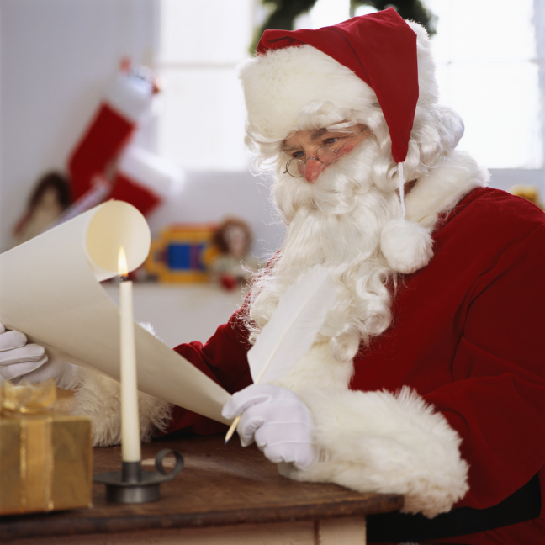

Santa checked his list not once but twice.

Of who was naughty or nice. From his list he understood

For a year Lulu and Amelia Beach had been good.

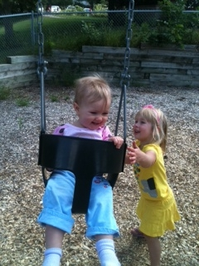

No presents to bring would be a terrible thing

It would be bad, The girls, Amelia and Lulu would be sad…

And Very…

GRUMPY

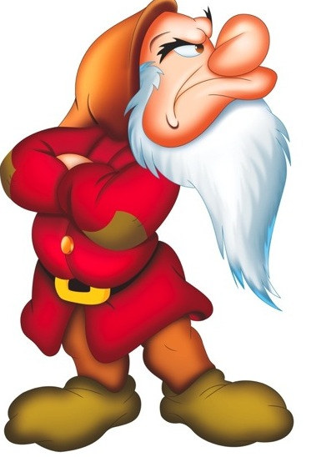

Elves came to help from near and far.

By plane, sled, train, by any means,

from the Netherlands & the land of dreams.

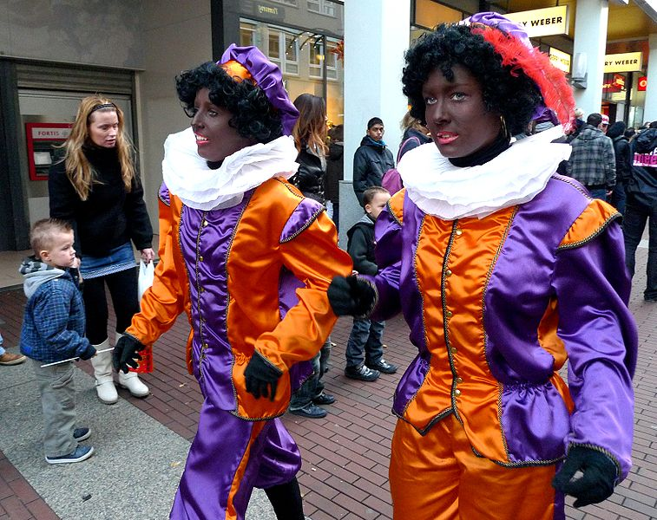

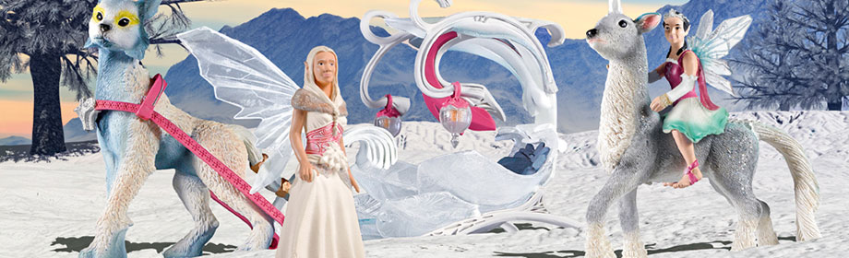

The keebler Elf left his tree to come to see.

The elf who lived with Harry Potter

came to help make it hotter.



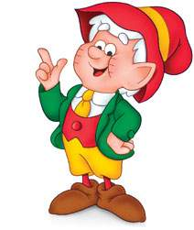 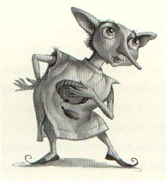

The North Pole elves with cheer and food

tried to make a happy mood.

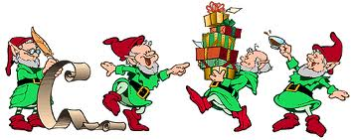

More elves came with magic and stars

and one with a bag of old Mars candy bars.

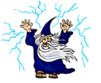 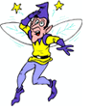 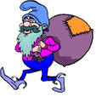

They said, we cannot leave

until we save Christmas Eve.

But nothing seemed to work.

Santa was jumpy and grumpy.

He left his sack and turned his back. There’s nothing more to say. Santa walked away.

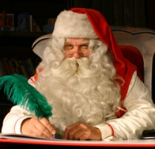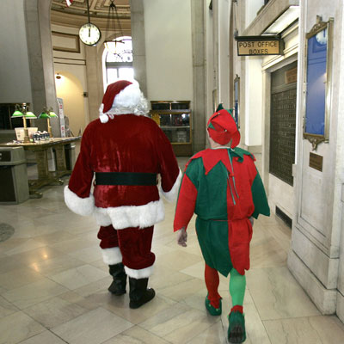

One of the elves, Northrop, was very very smart

He knew which came first, the horse or the cart.

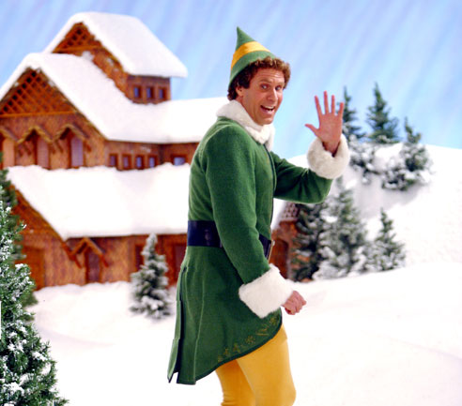

To Amelia and Lulu’s school Northrop went

To see, to get a hint.

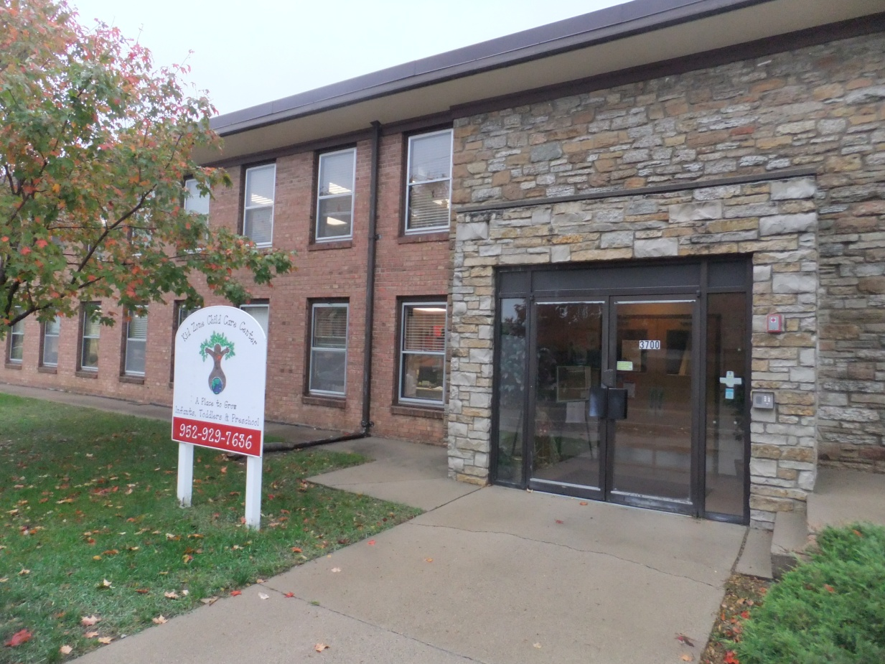

***He asked Amelia and Lulu***

***“Where should I move to?”***

Rudolf said,

“Lets go where we can play golf.”

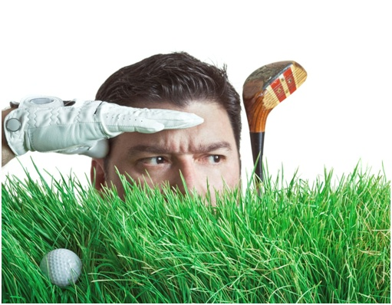

**No. Somewhere we can swim!!”**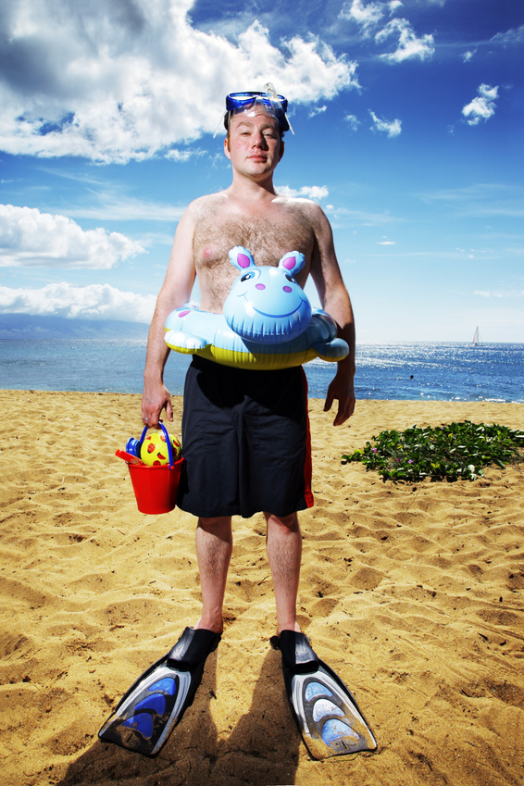

“Skip the sand. Let’s move to Disney Land.”



On the globe Northrop pointed to a dot.

“That’s where we go, that’s our spot.”

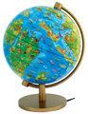

When it became too cold to stand

the people and animals moved to another land.

Beautiful Sunsets

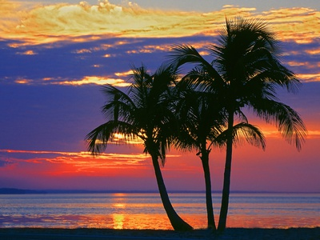

Beautiful blue water

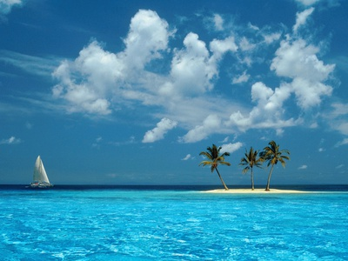

Sparkling sandy beaches

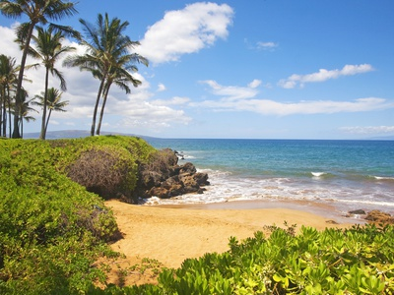

There are three islands very small

Perfect for elves who are not at all tall

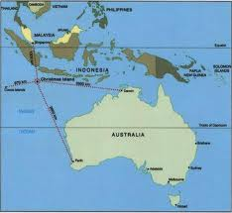

We will move to …..

“The Christmas Islands”

**Great idea !!! Lulu and Amelia’s whole family was happy.**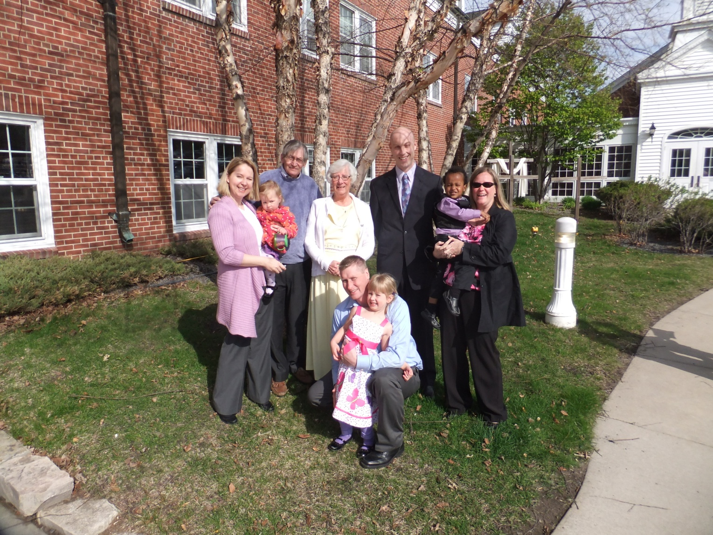

And clapped



**And Clapped**

Except

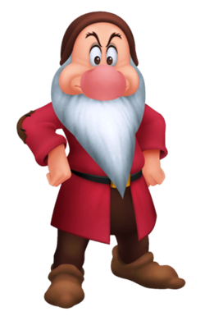

**“I love icicles not bicicles.**

**What trouble I’ve got. It will be just too hot.”**

The elves were happy

MC900140891.WMF

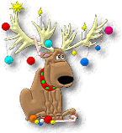

The reindeer were happy

The reindeer were happy

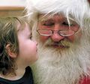

**Santa was happy and all the children were happy to see Santa.**

After Christmas truth be told

Santa started to miss the cold

and sitting in the sun became kind of old.

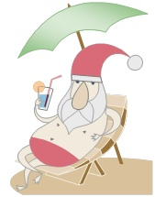

Then they did learn

It had warmed up, they could return.

As you might guess

they took the North Pole Express

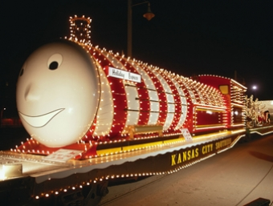

It was a splendid treat.

They took the sleigh to their very own street.

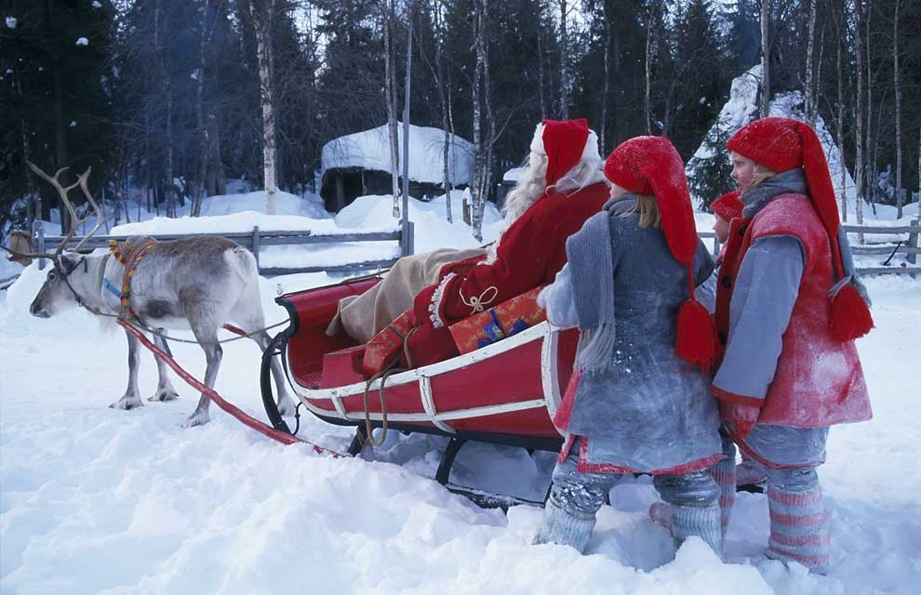

On being home all they could say was hooray.

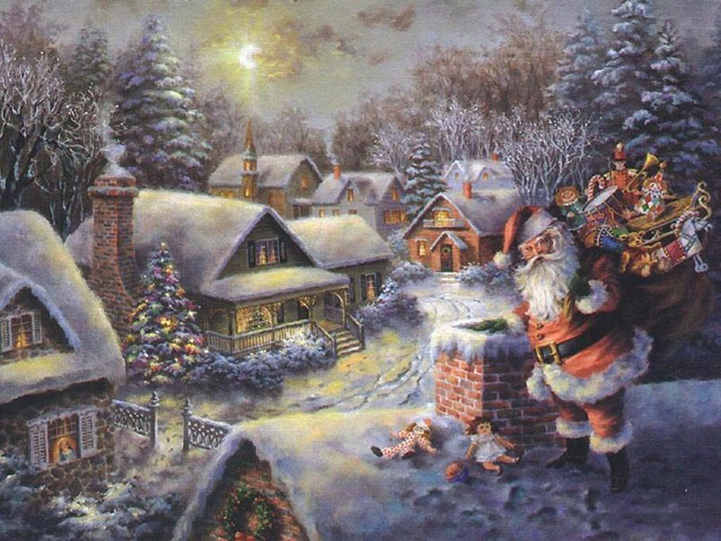

Santa had all of his joys.

Reading his stories by the fire and making toys

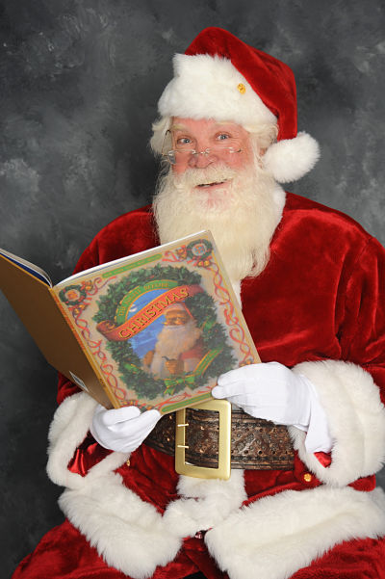 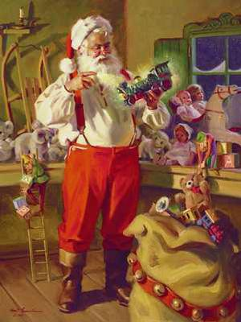 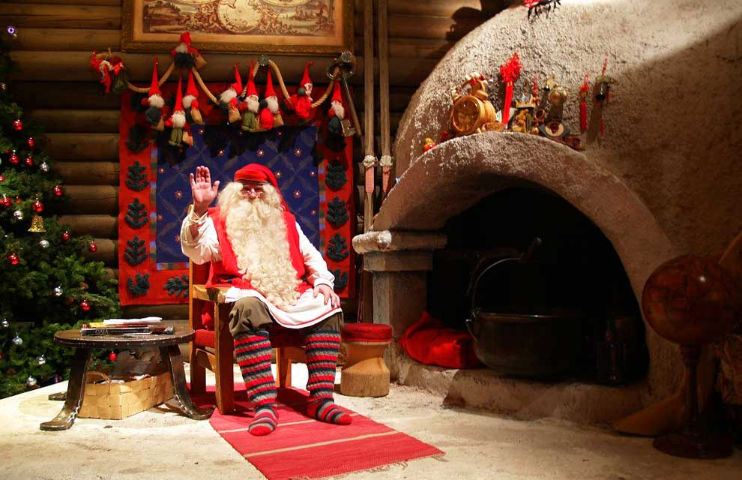

Only Grumpy complained

**It’s too cold to wear my swimming suit, I dislike icicles, and now I have to take the wheels off the sleigh.**



And there was a special note to Amelia and Lulu

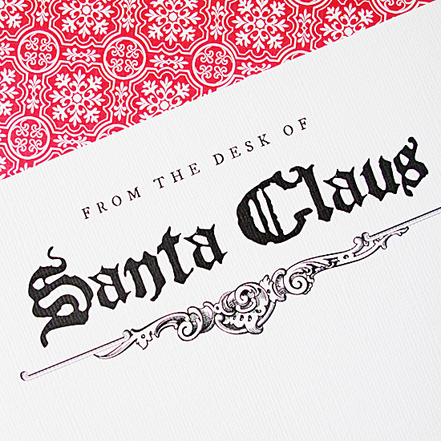

Dear Amelia and Lulu,

I had a wonderful time swimming and surfing. It was almost like a vacation, but I am glad to be home at the North Pole. If you want to see where those islands are, you and your parents can find the Christmas Islands on a map, or a globe or even the computer internet.

I am now busy making presents and toys for this coming Christmas in my cozy warm workshop. I will see you soon.

Love Santa



And Everyone Cheered.

